CSA1715-ARTIFICIAL INTELLIGENCE
LAB PROGRAM- 6
21-07-2026
- Write the python program for Vacuum Cleaner problem.

Aim
To write a Python program to implement the Vacuum Cleaner Problem using a Simple Reflex Agent.

Algorithm
- Initialize the two rooms with their current status (Clean/Dirty).
- Place the vacuum cleaner in the initial room.
- Check the status of the current room.
- If the room is dirty, clean it.
- If the room is already clean, move to the next room.
- Repeat the process until all rooms are clean.
- Display the final status of both rooms.

Program
rooms = {'A': 'Dirty', 'B': 'Dirty'}
location = 'A'

while True:
if rooms[location] == 'Dirty':
print("Cleaning", location)
rooms[location] = 'Clean'
else:
print(location, "is Clean")

if location == 'A':
location = 'B'
else:
break

print("\nFinal Room Status:")
print(rooms)

Output
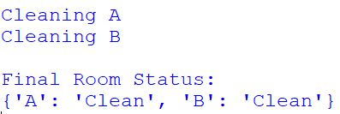
Result:
Thus, the Python program to implement the Vacuum Cleaner Problem using a Simple Reflex Agent was executed successfully.

